Statistical Analysis on factors influencing Life Expectancy
Name: YONGBO XIA
ID Number: 2255161

1.Abstract
Life expectancy, also referred to as the average lifespan, is undeniably a crucial indicator for assessing the population health status of a country or region. Historically, researchers have examined the determinants of life expectancy based on demographic variables such as age, gender, education level, income composition, and mortality rate. However, there has been a tendency to overlook the impact of immunization and the Human Development Index on life expectancy. This represents a significant research gap that needs to be addressed.
The objective of this report is to construct a more comprehensive and precise regression model by analyzing global data from 2000 to 2015. This model will encompass factors related to immunization, mortality rate factors, economic indicators, social determinants of health, and other health-related variables in order to investigate their specific influence on life expectancy. We firmly believe that establishing this model not only fills the aforementioned research gap but also furnishes robust scientific evidence for healthcare policy-making both in China and globally.
Within this report, we will develop a linear regression model for life expectancy as well as a logistic regression model specifically targeting life expectancies greater than 65 years old. Once these models are constructed successfully, we will address the following questions: What are the key variables influencing life expectancy? For countries with low life expectancies (≤65), what strategies should they adopt in order to improve their average life expectancies?

- Introduction
2.1 Background
The life expectancy serves as a crucial indicator of population health and well-being, reflecting the quality of healthcare infrastructure and overall socio-economic status within a country (Ho & Hendi, 2018). Achieving higher life expectancy is one of the main goals for improving the health of citizens in all countries around the world (Girosi & King, 2007). According to data compiled by the World Health Organization over the past decade or so, there has been a consistent upward trend in life expectancy across numerous countries worldwide. The majority of developed nations now boast an anticipated lifespan exceeding 65 years, while certain developing countries like China also exhibit similar longevity. Conversely, a significant proportion of countries with life expectancies below 65 years are predominantly situated in Africa, with a few scattered throughout the Middle East. These regions, characterized by limited development and prolonged periods of conflict, experience comparatively lower life expectancies.
2.2 literature review
To investigate the determinants of life expectancy in Asian countries, Uddin et al.(2023) conducted a comprehensive study by gathering annual panel data from 2002 to 2020 on various factors including carbon dioxide emissions, financial development, ecological footprint, healthcare infrastructure, birth rate, death rate, population size, and institutional quality. The CD test and the second-generation panel unit root test were employed, revealing that financial development, carbon dioxide emissions, and mortality rates exhibited non-stationarity at this level, while all other variables demonstrated stationarity at this level. In this case, they used the CS-ARDL model to analyze the data and concluded that the institutional quality index, financial development, CO2 emissions, ecological footprint, health expenditure, and birth rate positively impact life expectancy. Conversely, mortality rate and population growth negatively affect life expectancy in the short term. To determine the long-term effects, they used FMOLS and DOLS, and the results showed that the results are the same as those obtained with the CS-ARDL model. In summary, their research revealed that there have a positive correlation between life expectancy and institutional quality, financial development, and health spending, while indicating a negative association with other variables.
The impact of renewable energy, health spending, and GDP on life expectancy in Asian countries was examined in another study conducted by Dorbonova et al (2024). Annual data from 35 Asian economies for the period 2000 to 2020 were collected from the online database of World Bank. First, in order to assess the cross-sectional dependence of the variables, a Cross-Section Dependence Test was conducted, revealing evidence of cross-sectional dependence across the entire series of Asian countries. In light of this cross-sectional dependence, the CADF (Cross-Sectionally Augmented Dickey-Fuller) Unit Root Test was employed to obtain robust and reliable empirical estimates as well as policy recommendations. The findings indicated that all series exhibited stationarity at first differences with a significance level of 1%. Ultimately, it was concluded that both GDP and renewable energy exerted an influence on life expectancy at birth, while these three variables collectively impacted renewable energy.
Disease is also a significant determinant of life expectancy. Wang et al.(2022) conducted a comprehensive study on the impact of type 2 diabetes on life expectancy, gathering data on socio-demographic characteristics, lifestyle factors, medical history, and medication usage through touchscreen questionnaires or face-to-face interviews. A total of 316,995 participants were enrolled in the study with a median age of 57 years old; among them, 14,162 had type 2 diabetes and females accounted for 54% of this group. Through long-term follow-up with the participants, it was observed that individuals with type 2 diabetes had a shorter life expectancy compared to those without the condition; however, there was no statistically significant additional risk of mortality or reduction in overall life expectancy.
2.3 Aim
Through literature review, we have discovered that there are numerous factors that contribute to variations in life expectancy across different populations. These factors include, but are not limited to, access to healthcare, and socioeconomic conditions. Given the complexity of these factors and their potential interactions, this study aims to identify the key variables that have the most significant impact on life expectancy.
Moreover, we are particularly concerned with the countries that have a life expectancy of less than 65 years. These countries often face significant challenges in improving the health and well-being of their citizens. Therefore, our study will not only identify the key variables that affect life expectancy but will also suggest evidence-based strategies that these countries can adopt to improve their average life expectancy.

- Method
3.1 Data collection
The experimental data presented in this report were sourced exclusively from the World Health Organization. I have extracted 16 key data points from the summary statistics provided by the organization, encompassing metrics such as life expectancy, adult mortality rates, infant mortality rates and more for Turkmenistan between 2000 and 2015.
3.2 Data processing
The credibility of the report was enhanced by excluding outliers from the experimental data, thereby reducing bias. This exclusion process utilized the quartile and IQ2 methods. In this process, we first sorted the data, and then divided the data points into three parts based on the position of the quartiles: those less than or equal to Q1, those greater than or equal to Q3, and those between Q1 and Q3. Next, we used the IQR method, which is half the difference between Q3 and Q1, as the criterion to classify data points as outliers and exclude those less than Q1 - 1.5*IQ2R and greater than Q3 + 1.5*IQR. Through this method, we were able to more accurately assess the experimental results and thereby enhance the credibility of the report.
3.3 Exploratory data analysis
The utilization of R programming is essential in order to construct scatter plots for the analysis of multiple variables prior to the development of linear regression and logistic regression models.
By constructing scatter plots, we have identified four variables that exhibit a discernible linear relationship with life expectancy. These variables are denoted as BMI, Schooling(Number of years of Schooling ), total expenditure, and adult mortality. Based on the analysis of the corresponding scatter plots presented below, it is anticipated that both BMI and Schooling will positively influence life expectancy, while total expenditure and adult mortality may exert a negative impact.

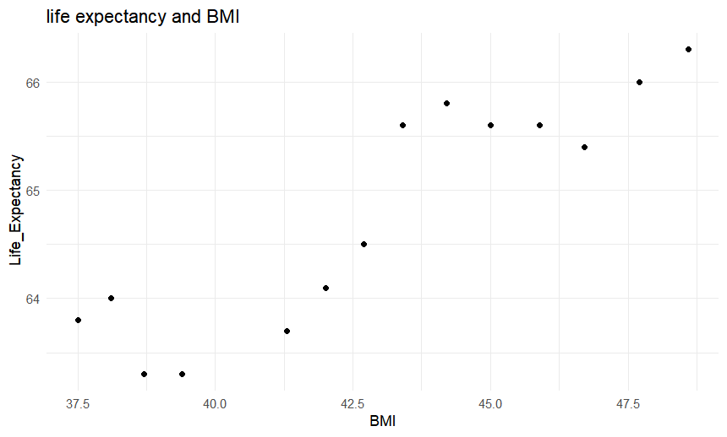

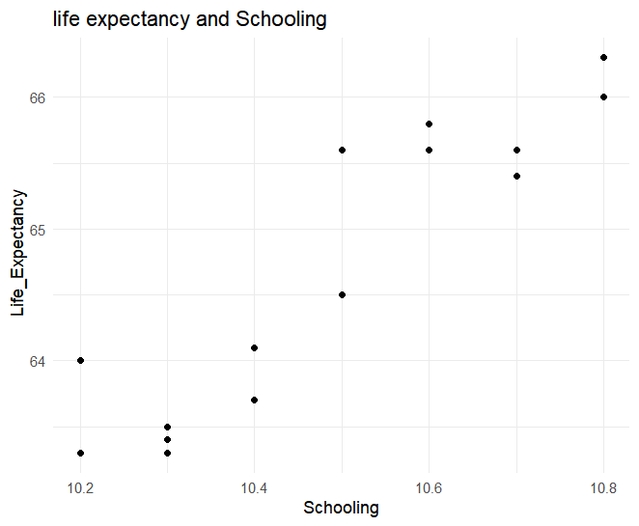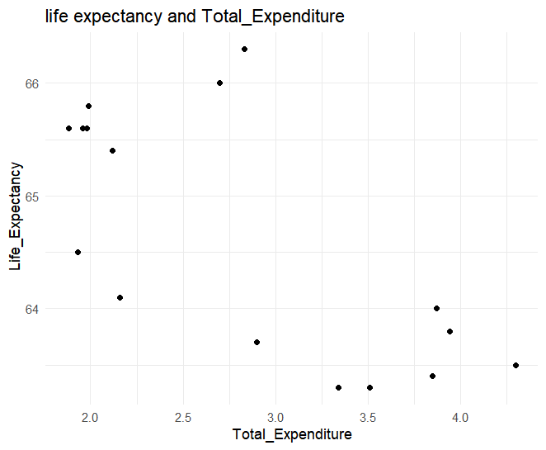
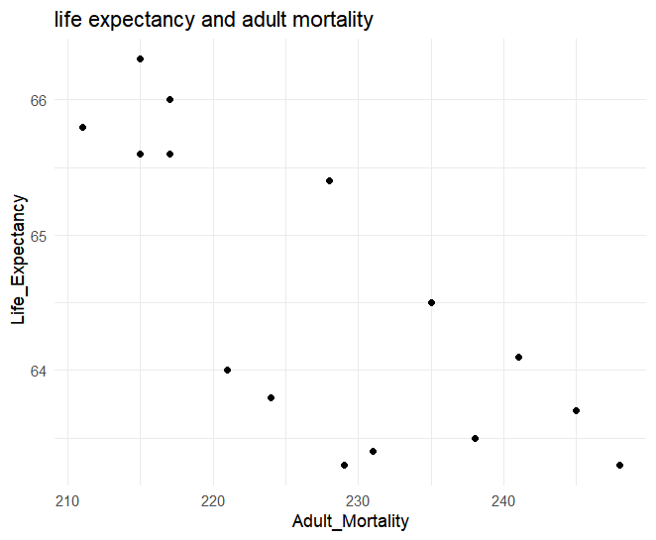

- Result and Discussion
  - Linear regression model (LRM)
After conducting a preliminary analysis and making predictions using scatter plots, it is possible to proceed with linear regression modeling，
BIM and Life expectance:

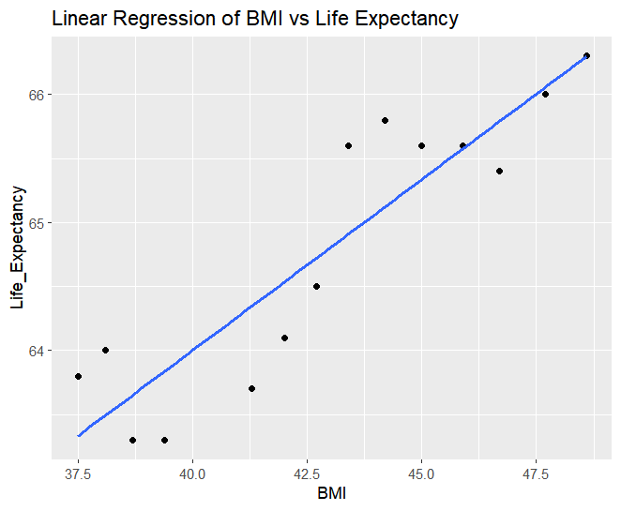
The Coefficients section reveals that the coefficient of BMI is positive and the p-value below the significance level (0.05). This suggests that as the increasing of BMI, the life expectancy of this country is increasing.
Schooling and Life expectancy:
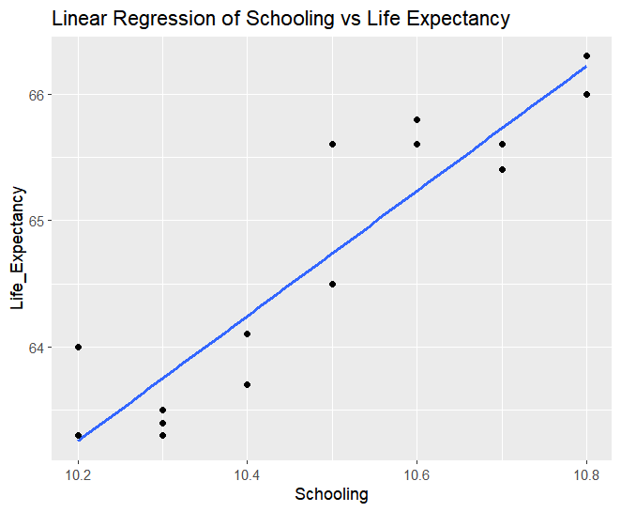
The positive coefficient of Schooling, coupled with a p-value below the significance level (0.05), signifies a significant association between an increase in years of education and an improvement in life expectancy.
Adult mortality and life expectancy:
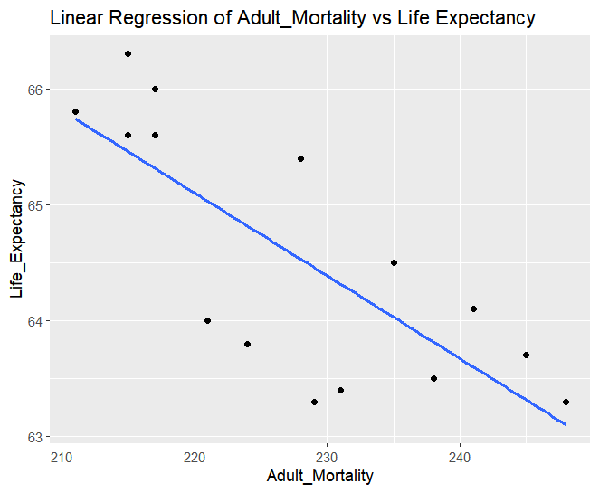
Based on the results in the Coefficients section, explain how adult mortality affects life expectancy. The coefficient for Adult_Mortality is negative and the p-value is less than the significance level (0.05), so an increase in adult mortality is associated with a decrease in life expectancy.
Total expenditure and life expectancy:
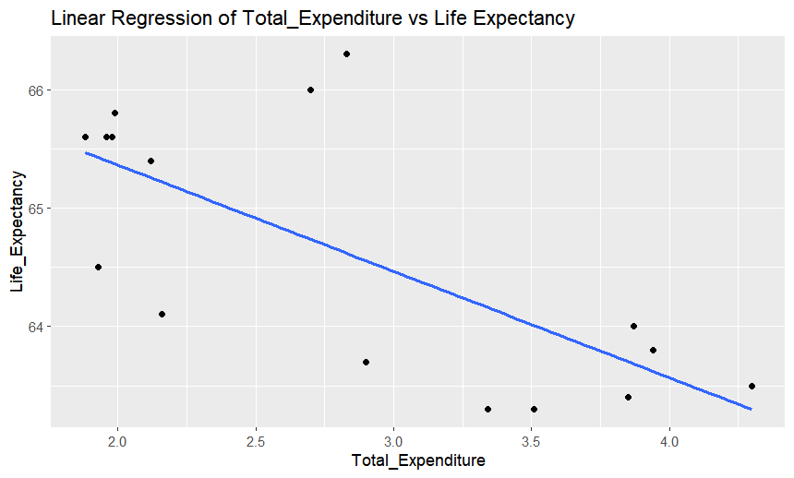
The positive correlation between total expenditures and life expectancy implies that an increase in total expenditures is associated with a corresponding increase in life expectancy.
  - Logic regression model
The objective of this section is to develop a logistic regression model for predicting whether the expected lifespan exceeds 65 years.
BMI and Life expectancy: According to the results from R programming, the BMI coefficient is positive, which indicates a positive correlation between BMI and an expected lifespan of over 65 years. Furthermore, the z-value is less than 0.05, indicating that BMI has a significant impact on an expected lifespan of over 65 years.

Life expectancy and Adult mortality: The R programming result revealed a negative coefficient sign for variable 'Adult mortality', indicating a negative correlation with the life expectancy of being over 65 years old. Furthermore, if the value of Z is less than 0.05, it signifies that variable Adult mortality significantly impacts the expected lifespan of over 65.
Schooling and life expectancy: the results obtained through R programming indicate a positive coefficient sign for schooling, suggesting a positive correlation between schooling and life expectancy greater than 65 years. Additionally, the z-value is less than 0.05, indicating that b significantly influences life expectancy greater than 65 years.
Life expectancy and Total expenditure: the analysis conducted through R programming reveals a negative coefficient sign for total expenditure, indicating a negative correlation with life expectancy exceeding 65 years. However, Z-value is greater than 0.05, it means that the impact of total expenditure on life expectancy exceeding 65 years is not significant.

- Conclusion
he correctness of our prediction has been validated based on the establishment of linear regression model and logistic regression model, indicating that BMI, Schooling, adult mortality rate, and total expenditure significantly impact life expectancy. Further analysis has revealed the pivotal factors with the greatest influence on life expectancy to be BMI, Schooling, and adult mortality rate.
Globally, there are significant differences in life expectancy among different countries. Some countries have lower life expectancies, and the reasons for this are varied, including economic levels, educational access, social environment, food safety, and medical conditions. For these countries with lower life expectancies, improving the overall health level, especially the educational access for minors, is particularly important.
Firstly, education is an important way to improve people's cognitive level, cultivate independent thinking ability, and form correct values. For minors, good education can help them establish a healthy lifestyle, improve their self-care awareness, and enhance their ability to recognize and avoid harmful things to their physical and mental health. For example, they can learn public health knowledge and understand the importance of dietary hygiene and personal hygiene to health, thus forming good hygiene habits in daily life. At the same time, they can also learn beneficial knowledge about environmental protection and physical exercise, guiding them to form a healthy lifestyle. Secondly, education has profound impacts on the physical and mental development of minors. Through learning, minors can continuously improve their knowledge level, broaden their horizons, enhance their self-confidence, and improve their sense of self-worth. All of these have a positive impact on their physical and mental health, thereby extending their expected lifespan.
However, in reality, many countries with lower expected lifespans are facing various development challenges, such as poverty, war, and disease. These factors seriously hinder these countries' efforts to extend their expected lifespans. Therefore, I believe that developed countries have the responsibility and ability to provide assistance to these countries. For example, providing support in food and healthcare can help improve people's living conditions and raise the overall health level of the population.
In summary, improving education access and improving people's living conditions is the key to extending expected lifespan. This requires the joint efforts of all of us. Let's work together to create a healthier and better world.

- Referense list

Bing Wang et al. (2022). ‘Assessing the impact of type 2 diabetes on mortality and life expectancy according to the number of risk factor targets achieved: an observational study.’, BMC Medicine. 3/13/2024, Vol. 22 Issue 1, p1-11. 11p. doi:
10.1186/s12916-024-03343-w.

Girosi, F., & King, G. (2007). ‘Understanding the Lee–Carter mortality forecasting method. Gking. Harvard. Edu.’, Available at: https://tinyurl.com/y2vdglrj

Ho, J., & Hendi, A. S. (2018). ‘Recent trends in life expectancy across high income countries: retrospective observational study. The BMJ.’ Available at:
https://doi.org/10.1136/bmj.k2562

Ijaz Uddin et ai. (2023). ‘Revisiting the determinants of life expectancy in Asia—exploring the role of institutional quality, fnancial development, and environmental degradation.’, Environment, Development & Sustainability. May2024, Vol. 26 Issue 5, p11289-11309. 21p. doi: 10.1007/s10668-023-03283-0

Iraima DORBONOVA et al. (2022) ‘ANALYZING THE RELATIONSHIP BETWEEN HEALTH EXPENDITURE, RENEWABLE ENERGY AND LIFE EXPECTANCY: EVIDENCE FROM ASIAN COUNTRIES.’, Journal of Economic & Social Research / ESAM Ekonomik ve Sosyal Araştırmalar Dergisi. bahar2024, Vol. 5 Issue 1, p111-134. 24p. doi: 10.53662/esamdergisi.1459607

- Appendix
  - The R codes of scatter plots:
library(ggplot2)
df <- data.frame(
Life_Expectancy = c(66.3, 66, 65.4, 65.6, 65.8, 65.6, 64.5, 64.1, 63.7, 63.3, 63.5, 63.4, 63.3, 64, 63.8),
Adult_Mortality = c(215, 217, 228, 217, 211, 215, 235, 241, 245, 248, 238, 231, 229, 221, 224)
)
ggplot(df, aes(x = Adult_Mortality, y = Life_Expectancy)) +
geom_point() +
labs(title = "life expectancy and adult mortality", x = "Adult_Mortality", y = " Life_Expectancy") +
theme_minimal()

library(ggplot2)
df <- data.frame(
Life_Expectancy = c(66.3, 66, 65.4, 65.6, 65.6, 65.8, 65.6, 64.5, 64.1, 63.7, 63.3, 63.5, 63.4, 63.3, 64, 63.8),
Alcohol = c(2.65, 2.9, 2.93, 2.75, 2.55, 2.48, 2.35, 2.4, 2.58, 2.71, 2.85, 2.86, 2.88, 2.33, 2.35, 2.9)
)
ggplot(df, aes(x = Alcohol, y = Life_Expectancy)) +
geom_point() +
labs(title = "Life_Expectancy and Alcohol", x = "Alcohol", y = "Life_Expectancy") +
theme_minimal()

library(ggplot2)
#
df <- data.frame(
Life_Expectancy = c(66.3, 65.4, 65.6, 65.8, 65.6, 64.5, 64.1, 63.7, 63.3, 63.5, 63.4, 63.3, 64, 63.8),
Percentage_Expenditure = c(0, 63.7481117, 490.4181326, 385.325164, 37.88466056, 34.23979419, 0.358651421, 29.27235366, 2.19888585, 186.1013972, 179.6156482, 130.3784829, 106.180706, 88.2436347)
)
ggplot(df, aes(x = Percentage_Expenditure, y = Life_Expectancy)) +
geom_point() +
labs(title = "Life_Expectancy and Percentage_Expenditure", x = "Percentage_Expenditure", y = "Life_Expectancy") +
theme_minimal()

library(ggplot2)
df <- data.frame(
Life_Expectancy = c(66.3, 66, 65.4, 65.6, 65.6, 65.8, 65.6, 64.5, 64.1, 63.7, 63.3, 63.5, 63.4, 63.3, 64, 63.8),
Hepatitis_B = c(99, 97, 98, 98, 97, 96, 97, 96, 98, 98, 99, 96, 97, 96,97,97)
)
ggplot(df, aes(x = Hepatitis_B, y = Life_Expectancy)) +
geom_point() +
labs(title = "Life_Expectancy and Hepatitis_B", x = "Hepatitis_B", y = "Life_Expectancy") +
theme_minimal()

library(ggplot2)
df <- data.frame(
Life_Expectancy = c(66.3, 66, 65.4, 65.6, 65.6, 65.8, 65.6, 64.5, 63.3, 63.5, 63.4, 63.3, 64),
Measles= c(0,0,0,0,0,0,0,0,0,1,1,11,9)
)
ggplot(df, aes(x = Measles, y = Life_Expectancy)) +
geom_point() +
labs(title = "life expectancy and Measles", x = "Measles", y = " Life_Expectancy") +
theme_minimal()

library(ggplot2)
df <- data.frame(
Life_Expectancy = c(66.3, 66, 65.4, 65.6, 65.6, 65.8, 65.6, 64.5, 64.1, 63.7, 63.3, 63.3, 64, 63.8),
BMI = c(48.6, 47.7, 46.7, 45.9, 45, 44.2, 43.4, 42.7, 42, 41.3, 39.4, 38.7, 38.1, 37.5)
)
ggplot(df, aes(x = BMI, y = Life_Expectancy)) +
geom_point() +
labs(title = "life expectancy and BMI", x = "BMI", y = " Life_Expectancy") +
theme_minimal()

library(ggplot2)
df <- data.frame(
Life_Expectancy = c(66.3, 66, 65.4, 65.6, 65.6, 65.8, 65.6, 64.5, 64.1, 63.7, 63.3, 63.5, 63.4, 63.3, 64, 63.8),
Under_Five_Deaths = c(7,8,8,8,8,8,8,8,8,8,8,8,8,8,9,9)
)
ggplot(df, aes(x = Under_Five_Deaths, y = Life_Expectancy)) +
geom_point() +
labs(title = "life expectancy and Under_Five_Deaths", x = "Under_Five_Deaths", y = " Life_Expectancy") +
theme_minimal()

library(ggplot2)
df <- data.frame(
Life_Expectancy = c(66.3, 66, 65.4, 65.6, 65.6, 65.8, 65.6, 64.5, 64.1, 63.7, 63.3, 63.5, 63.4, 63.3, 64, 63.8),
Polio = c(99, 98, 98, 98, 97, 96, 97, 96, 98, 98, 99, 98, 66, 99, 94, 98)
)
ggplot(df, aes(x = Polio, y = Life_Expectancy)) +
geom_point() +
labs(title = "life expectancy and Polio", x = "Polio", y = " Life_Expectancy") +
theme_minimal()

library(ggplot2)
df <- data.frame(
Life_Expectancy = c(66.3, 66, 65.4, 65.6, 65.6, 65.8, 65.6, 64.5, 64.1, 63.7, 63.3, 63.5, 63.4, 63.3, 64, 63.8),
Total_Expenditure = c(2.83, 2.7, 2.12, 1.96, 1.98, 1.99, 1.88, 1.93, 2.16, 2.9, 3.51, 4.3, 3.85, 3.34, 3.87, 3.94)
)
ggplot(df, aes(x = Total_Expenditure, y = Life_Expectancy)) +
geom_point() +
labs(title = "life expectancy and Total_Expenditure", x = "Total_Expenditure", y = " Life_Expectancy") +
theme_minimal()

library(ggplot2)
df <- data.frame(
Life_Expectancy = c(66.3, 66, 65.4, 65.6, 65.6, 65.8, 65.6, 64.5, 64.1, 63.7, 63.3, 63.5, 63.4, 63.3, 64, 63.8),
Diphtheria = c(99, 98, 98, 97, 97, 96, 96, 96, 98, 98, 99, 97, 83, 98, 95, 97)
)
ggplot(df, aes(x = Diphtheria, y = Life_Expectancy)) +
geom_point() +
labs(title = "life expectancy and Diphtheria", x = "Diphtheria", y = " Life_Expectancy") +
theme_minimal()

library(ggplot2)
df <- data.frame(
Life_Expectancy = c(66.3, 66, 65.4, 65.6, 65.6, 65.8, 65.6, 64.5, 64.1, 63.7, 63.3, 63.5, 63.4, 63.3, 64, 63.8),
Thinness_1_19_Years = c(3.3, 3.3, 3.2, 3.2, 3.2, 3.2, 3.2, 3.2, 3.3, 3.3, 3.4, 3.4, 3.5, 3.5, 3.6, 3.6)
)
ggplot(df, aes(x = Thinness_1_19_Years, y = Life_Expectancy)) +
geom_point() +
labs(title = "life expectancy and Thinness_1_19_Years", x = "Thinness_1_19_Years", y = " Life_Expectancy") +
theme_minimal()

library(ggplot2)
df <- data.frame(
Life_Expectancy = c(66.3, 66, 65.4, 65.6, 65.6, 65.8, 65.6, 64.5, 64.1, 63.7, 63.3, 63.5, 63.4, 63.3, 64, 63.8),
Thinness_5_9_Years = c(3.3, 3.3, 3.3, 3.3, 3.3, 3.3, 3.3, 3.3, 3.3, 3.3, 3.4, 3.4, 3.4, 3.5, 3.5, 3.6)
)
ggplot(df, aes(x = Thinness_5_9_Years, y = Life_Expectancy)) +
geom_point() +
labs(title = "life expectancy and Thinness_5_9_Years", x = "Thinness_5_9_Years", y = " Life_Expectancy") +
theme_minimal()

library(ggplot2)
df <- data.frame(
Life_Expectancy = c(66.3, 66, 65.4, 65.6, 65.6, 65.8, 65.6, 64.5, 64.1, 63.7, 63.3, 63.5, 63.4, 63.3, 64, 63.8),
Income_Composition_of_Resources=c(0.688, 0.683, 0.678, 0.672, 0.665, 0, 0, 0, 0, 0, 0, 0, 0, 0, 0, 0)
)
ggplot(df, aes(x = Income_Composition_of_Resources, y = Life_Expectancy)) +
geom_point() +
labs(title = "life expectancy and Income_Composition_of_Resources", x = "Income_Composition_of_Resources", y = " Life_Expectancy") +
theme_minimal()

library(ggplot2)
df <- data.frame(
Life_Expectancy = c(66.3, 66, 65.4, 65.6, 65.6, 65.8, 65.6, 64.5, 64.1, 63.7, 63.3, 63.5, 63.4, 63.3, 64),
Schooling = c(10.8, 10.8, 10.7, 10.7, 10.6, 10.6, 10.5, 10.5, 10.4, 10.4, 10.3, 10.3, 10.3, 10.2, 10.2)
)
ggplot(df, aes(x = Schooling, y = Life_Expectancy)) +
geom_point() +
labs(title = "life expectancy and Schooling", x = "Schooling", y = " Life_Expectancy") +
theme_minimal()

library(ggplot2)

df <- data.frame(
Life_Expectancy = c(66.3, 66, 65.4, 65.6, 65.6, 65.8, 65.6, 64.5, 64.1, 63.7, 63.3, 63.5, 63.4, 63.3, 64, 63.8),
Infant_Deaths = c(6, 7, 7 ,7 ,7, 7, 6, 6, 6, 6, 6, 6, 7, 7 ,7, 7)
)
ggplot(df, aes(x = Infant_Deaths, y = Life_Expectancy)) +
geom_point() +
labs(title = "life expectancy and Infant_Deaths", x = "Infant_Deaths", y = " Life_Expectancy") +
theme_minimal()

7.2 The R codes of linear regression model (LRM)
library(ggplot2)
Life_Expectancy = c(66.3, 66, 65.4, 65.6, 65.8, 65.6, 64.5, 64.1, 63.7, 63.3, 63.5, 63.4, 63.3, 64, 63.8)
Adult_Mortality = c(215, 217, 228, 217, 211, 215, 235, 241, 245, 248, 238, 231, 229, 221, 224)
data <- data.frame(Life_Expectancy, Adult_Mortality)
linear_model <- lm(Adult_Mortality ~ Life_Expectancy, data = data)
summary(linear_model)
ggplot(data, aes(x = Adult_Mortality, y = Life_Expectancy)) +
geom_point() +
geom_smooth(method = "lm", se = FALSE) +
labs(title = "Linear Regression of Adult_Mortality vs Life Expectancy",
x = "Adult_Mortality", y = "Life_Expectancy")

library(ggplot2)
Life_Expectancy = c(66.3, 66, 65.4, 65.6, 65.6, 65.8, 65.6, 64.5, 64.1, 63.7, 63.3, 63.5, 63.4, 63.3, 64)
Schooling = c(10.8, 10.8, 10.7, 10.7, 10.6, 10.6, 10.5, 10.5, 10.4, 10.4, 10.3, 10.3, 10.3, 10.2, 10.2)
data <- data.frame(Life_Expectancy, Schooling)
linear_model <- lm(Schooling ~ Life_Expectancy, data = data)
summary(linear_model)
ggplot(data, aes(x = Schooling, y = Life_Expectancy)) +
geom_point() +
geom_smooth(method = "lm", se = FALSE) +
labs(title = "Linear Regression of Schooling vs Life Expectancy",
x = "Schooling", y = "Life_Expectancy")

library(ggplot2)
Life_Expectancy = c(66.3, 66, 65.4, 65.6, 65.6, 65.8, 65.6, 64.5, 64.1, 63.7, 63.3, 63.3, 64, 63.8)
BMI = c(48.6, 47.7, 46.7, 45.9, 45, 44.2, 43.4, 42.7, 42, 41.3, 39.4, 38.7, 38.1, 37.5)
data <- data.frame(Life_Expectancy, BMI)
linear_model <- lm(BMI ~ Life_Expectancy, data = data)
summary(linear_model)
ggplot(data, aes(x = BMI, y = Life_Expectancy)) +
geom_point() +
geom_smooth(method = "lm", se = FALSE) +
labs(title = "Linear Regression of BMI vs Life Expectancy",
x = "BMI", y = "Life_Expectancy")

library(ggplot2)
Life_Expectancy = c(66.3, 66, 65.4, 65.6, 65.6, 65.8, 65.6, 64.5, 64.1, 63.7, 63.3, 63.5, 63.4, 63.3, 64, 63.8)
Total_Expenditure = c(2.83, 2.7, 2.12, 1.96, 1.98, 1.99, 1.88, 1.93, 2.16, 2.9, 3.51, 4.3, 3.85, 3.34, 3.87, 3.94)
data <- data.frame(Life_Expectancy, Total_Expenditure)
linear_model <- lm(Total_Expenditure ~ Life_Expectancy, data = data)
summary(linear_model)
ggplot(data, aes(x = Total_Expenditure, y = Life_Expectancy)) +
geom_point() +
geom_smooth(method = "lm", se = FALSE) +
labs(title = "Linear Regression of Total_Expenditure vs Life Expectancy",
x = "Total_Expenditure", y = "Life_Expectancy")

  - The R codes of logic regression model
#BMI vs Life Expectancy
Life_Expectancy <- c(66.3, 66, 65.4, 65.6, 65.6, 65.8, 65.6, 64.5, 64.1, 63.7, 63.3, 63.3, 64, 63.8)
BMI <- c(48.6, 47.7, 46.7, 45.9, 45, 44.2, 43.4, 42.7, 42, 41.3, 39.4, 38.7, 38.1, 37.5)
Life_Expectancy_Binary <- ifelse(Life_Expectancy > 65, 1, 0)
df <- data.frame(Life_Expectancy_Binary, BMI)
# Fit a logistic regression model using the glm() function
# family=binomial(link="logit") denotes logistic regression
logistic_model <- glm(Life_Expectancy_Binary ~ BMI, data = df, family = binomial(link = "logit"))
summary(logistic_model)
new_BMI <- c(45, 40, 35)
new_data <- data.frame(BMI = new_BMI)
# Use the model to make predictions
predictions <- predict(logistic_model, newdata = new_data, type = "response")
print(predictions)
predicted_classes <- ifelse(predictions > 0.5, 1, 0)
print(predicted_classes)

# Life_Expectancy vs Adult_Mortality
Life_Expectancy <- c(66.3, 66, 65.4, 65.6, 65.8, 65.6, 64.5, 64.1, 63.7, 63.3, 63.5, 63.4, 63.3, 64, 63.8)
Adult_Mortality <- c(215, 217, 228, 217, 211, 215, 235, 241, 245, 248, 238, 231, 229, 221, 224)
Life_Expectancy_Binary <- ifelse(Life_Expectancy > 65, 1, 0)
df <- data.frame(Life_Expectancy_Binary, Adult_Mortality)
logistic_model <- glm(Life_Expectancy_Binary ~ Adult_Mortality, data = df, family = binomial(link = "logit"))
summary(logistic_model)
new_Adult_Mortality <- c(200, 250, 300)
new_data <- data.frame(Adult_Mortality = new_Adult_Mortality)
predictions <- predict(logistic_model, newdata = new_data, type = "response")
print(predictions)
predicted_classes <- ifelse(predictions > 0.5, 1, 0)
print(predicted_classes)

# Life_Expectancy vs Schooling
Life_Expectancy <- c(66.3, 66, 65.4, 65.6, 65.6, 65.8, 65.6, 64.5, 64.1, 63.7, 63.3, 63.5, 63.4, 63.3, 64)
Schooling <- c(10.8, 10.8, 10.7, 10.7, 10.6, 10.6, 10.5, 10.5, 10.4, 10.4, 10.3, 10.3, 10.3, 10.2, 10.2)
Life_Expectancy_Binary <- ifelse(Life_Expectancy > 65, 1, 0)
df <- data.frame(Life_Expectancy_Binary, Schooling)
logistic_model <- glm(Life_Expectancy_Binary ~ Schooling, data = df, family = binomial(link = "logit"))
summary(logistic_model)
new_Schooling <- c(10.5, 10.7, 11.0)
new_data <- data.frame(Schooling = new_Schooling)
predictions <- predict(logistic_model, newdata = new_data, type = "response")
print(predictions)
predicted_classes <- ifelse(predictions > 0.5, 1, 0)
print(predicted_classes)

# Life_Expectancy vs Total_Expenditure
Life_Expectancy <- c(66.3, 66, 65.4, 65.6, 65.6, 65.8, 65.6, 64.5, 64.1, 63.7, 63.3, 63.5, 63.4, 63.3, 64, 63.8)
Total_Expenditure <- c(2.83, 2.7, 2.12, 1.96, 1.98, 1.99, 1.88, 1.93, 2.16, 2.9, 3.51, 4.3, 3.85, 3.34, 3.87, 3.94)
Life_Expectancy_Binary <- ifelse(Life_Expectancy > 65, 1, 0)
df <- data.frame(Life_Expectancy_Binary, Total_Expenditure)
logistic_model <- glm(Life_Expectancy_Binary ~ Total_Expenditure, data = df, family = binomial(link = "logit"))
summary(logistic_model)
new_Total_Expenditure <- c(2.5, 3.5, 4.5)
new_data <- data.frame(Total_Expenditure = new_Total_Expenditure)
predictions <- predict(logistic_model, newdata = new_data, type = "response")
print(predictions)
predicted_classes <- ifelse(predictions > 0.5, 1, 0)
print(predicted_classes)

